Title: Can AI Art sneak its way in?

(*** This BGG forum post was composed as a course requirement for an undergraduate Data Ethics course at The University of Chicago, SP23). Participation in the survey (~3 min) and discussion in the forum is encouraged and welcome from everyone. Although data will be collected and shared in a final presentation, all references will be made anonymous. Passion (whether for or against) the subject matter is appreciated!

**Preface:**

In recent years with the advancement of AI and growing image databases, Artificially Generated Art (AI Art) has become a popular way of “creating” by simply inputting a description of a desired image. With the rise of this new technology, however, emerges the issue of ethics and plagiarism. AI art necessarily needs to draw on a database of word-associated images to create an image matching the input description. Some stand on the side that due to the variety of images used, AI art could be considered as inspired the same way a human artist might be inspired by images they have seen in their lives. Those on the other side condemn AI art as completely unoriginal and a blatant act of plagiarism. While the line between the two remains legally hazy I want to inquire, does AI art have a place in the board game industry?

**Mysterium: A potential AI art candidate?**

Setting aside the question of ethicality (for now), something I’d like to know is whether or not AI art truly removes something from the core gameplay of a game. In many forum posts on the subject and in the comments of crowdfunding projects (ie. <https://gamefound.com/projects/archangelisgames/archangelis?ref=search>) I found many arguments against the usage of AI art because it gives a game less artistic depth or simply detracts from the gaming experience in some way. In order to collect some more feedback on the issue I’ve designed a simple survey focused around the game Mysterium (2015, <https://boardgamegeek.com/boardgame/181304/mysterium>). I chose this game due to its popular reception (ranked 343 on BGG overall) and the art being an integral part of how the game actually plays. Using the free AI art generator, Dream by Wombo (<https://dream.ai/create>), I created some of the images below from image prompts that I felt might fit into the dream-like theme of the vision cards in Mysterium. As a disclaimer I do not claim any of these images as my own intellectual property but I do include them here in order to help explore this topic more. It would be a great help if you could answer the survey questions below:

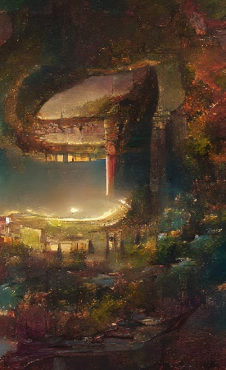 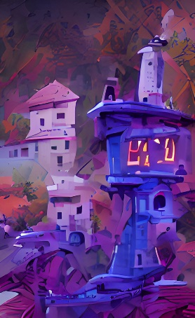

Survey Questions:

* Do you believe that the art of Mysterium has a common theme?
  + Yes, No
  + If so, how would you describe it?
* Which (if any) of these images look like they could be effectively used as vision cards in a game of Mysterium?
  + 1,2,3,4,5,6,7,8,9,10

**Costs and Benefits:**

Having never designed a board game myself, I would like to ask the community (especially game designers, producers, and artists) about how they think AI art affects the process of hiring artists for a game.

* Have you participated in or genuinely thought of creating a board game in the last 2 years?
  + Yes, No
* How important do you consider art to be in a board game (specifically yours if you answered yes above)?
  + Scale from 1 to 10, 1 being irrelevant, 10 being the most important attribute
* How important do you consider the artists involved in your board game creation?
  + Scale from 1 o 10, 1 being irrelevant, 10 being the most important members of the team
* Did you consider using AI art in your game?
  + Yes- for a lot of the art
  + Yes- for miscellaneous things
  + No
* Do you think AI art is a cheaper (in terms of finance, time and manpower) alternative to hiring live artists?
  + Yes, No
* Do you think using AI art would negatively affect the reception of your game?
  + Yes, No
* Would you hire an artist who used AI art in their art creation process?
  + Yes, No

**Ethics:**

Finally, I want to get a better grasp of the community’s view of the ethics of AI art. You might ask, why put this last, it ought to be the first and most important part of the conversation. In part I agree, because if the entirety of AI art is hit with the ‘plagiarism’ tag then this entire discussion is mute and we should put it on the backburner, never to look back. Nevertheless, convenience always seems to have a way of loosening moral standards in commercial society. Thus, I thought the earlier discussions might be interesting and of some relevance. I know the question below can be a little more nuanced than the options given, so please feel free to elaborate on your answer in the comment. Without any further rambling:

* Do you believe the usage of AI is/can be ethical?
  + Yes, maybe, No

**Final Note:**

This post isn’t meant to bias anyone in one direction or another, just to encourage more discussion on a topic that I find very interesting. I love board games and while I have my favorites and my ‘mehs,’ I can appreciate that each creation is the product of people coming together to create something for others to enjoy. It’s my hope that this discussion adds to the myriad of ideas in this space; that anyone focused on the costs can also recognize the benefits, and vice versa. Ultimately, AI art is a tool and its alignment is dependent on how it’s used.

Poster Parts:

Background:

* What is AI Art?
  + Been around since 1956, and includes any artwork, particularly images and musical compositions, created through the use of artificial intelligence programs such as text-to-image models and musical generators. This project focuses on the image form of art
* Current main AI art generators:
  + Stable Diffusion, Dall-e 2, Dreams by Wombo, Jasper Art, Nighcafe, Imagen by Google, etc.
  + Most of these allow you to claim generated art as your own artwork! You own the art created from text that you input!

Motivation:

* Example of in-dreams: completely generated AI art game that made 12,036.00 on Gamefound. Completely using AI generated art-work.
* Comment from the creator concerning usage of AI in artwork:
  + “I hear what you're saying Greg. AI / neural network art is a complex and polarizing topic, and the breadth of the discussion is expanding every day it seems. For what it's worth, here's what I can tell you as one of the designers: Mike and I designed the game around the art, rather than adding the art to a designed game. We knew the art wouldn't cut it in a normal game because it's less clear, less composed, etc than what a real artist could produce. So the surreal, subtly wrong, dreamlike art informed the theme of exploring dreams, turning the seeming weaknesses of the art into a strength. It also took many hours of "curating" the generated art, as I call it, tweaking text prompts and running it again and again, looking for images that evoked more emotions and ideas than others. That curation process by Mike and I means that there is a human component to the art, albeit to a lesser degree. Mike even photoshopped elements from one image to another in some cases to achieve a better composition. But if we hadn't designed the entire game around the art in the first place, we would have hired an artist for sure”

Issue:

* AI art is considered to be plagiarism or a less form of artwork because it lacks the aspect of human creativity.

Research Questions:

* Does AI enhanced/generated art represent an affordable and effective alternative to hiring artists? If so, would designers consider using AI art more? If not,
* AI art generators offer a cheaper alternative to finding and hiring an artist to do the art for a board game. Do board game designers and producers believe AI art can be just as effective?
* What effect does knowing a game has AI generated artwork have on the reception of the game? If negative, does
* AI art is about replicability. I trained some of the images with an image taken from Mysterium at the ‘weak’ setting

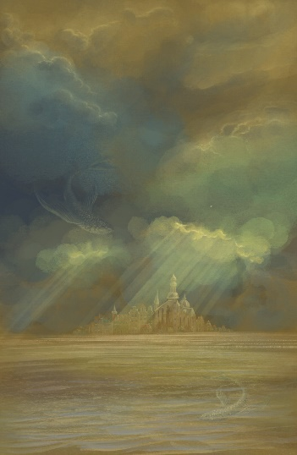

art that was used as training data

Average rating of

Conclusions:

* Responders generally value board game

Observations:

* Responders generally
  + Value board game art and artists
  + Believe AI is cheaper than hiring artists
  + Believe AI art would negatively affect the reception of a game
  + Do not consider using AI art in the Game Design process
  + Are conflicted as to whether AI art can be used Ethically in Board Games

Surprises:

Further study:

* Something that the survey lacked was correlating responses to questions with one another. I did not realize that I would not be able to see what one user answered for each question, only the aggregate responses to each question. A future study could be designed to consider the correlation between answers to each question. Questions such as, do people who don’t believe AI art would negatively affect the reception of their game consider using AI art in their game?
* Also would use the term ‘affordable’ rather than ‘cheap’
  + In survey would define ethics before asking the last question about the usage of AI art